Apply filters to SQL queries

Project description
In this project, I used SQL to filter database records to investigate potential security incidents and manage organizational updates. By querying the log_in_attempts and employees tables, I applied various filters to isolate suspicious activity and identify specific employee groups. These tasks demonstrate how to use SQL to refine data retrieval for effective security analysis and administrative oversight.

Retrieve after hours failed login attempts
To investigate a potential security incident, I needed to identify failed login attempts that occurred after business hours (after 18:00).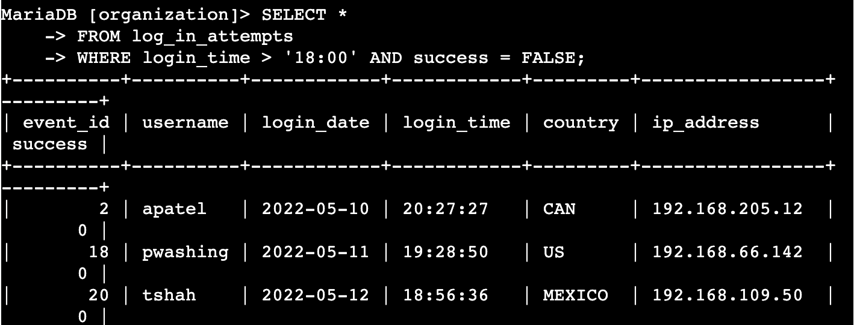
How the query works:
This query selects all columns from the log_in_attempts table. It uses the AND operator to satisfy two conditions: the login_time must be greater than '18:00:00' (6:00 PM), and the success column must equal 0 (or FALSE), which indicates a failed login. This allows me to focus specifically on unauthorized access attempts occurring late at night.

Retrieve login attempts on specific dates
A suspicious event occurred on 2022-05-09. I investigated all login attempts from that day and the day before to find related patterns.
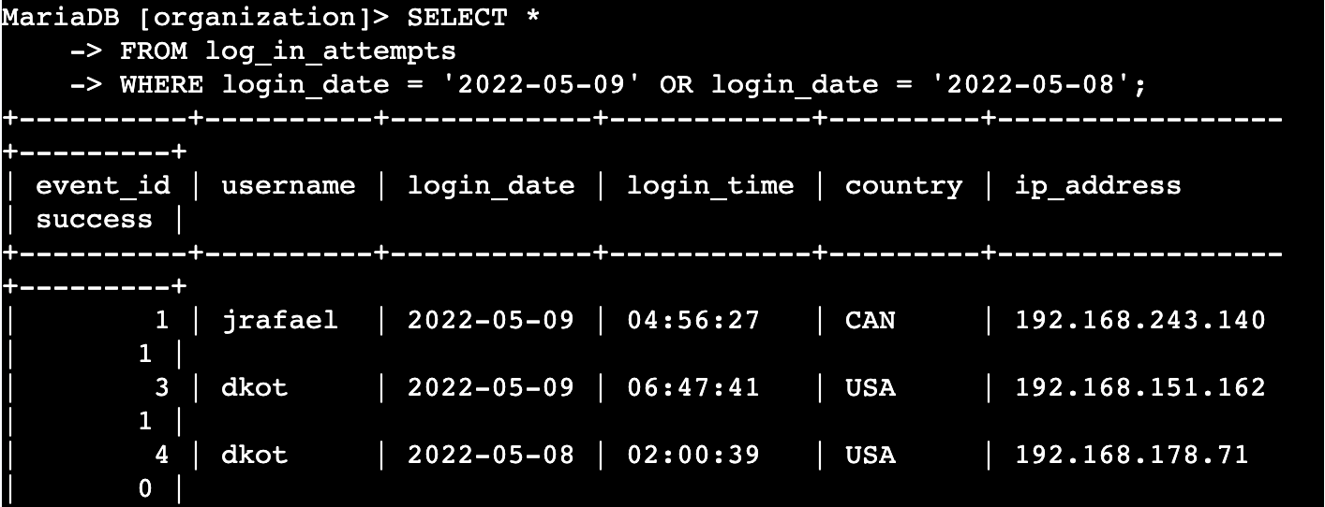
How the query works: This query uses the OR operator to filter for two specific dates in the login_date column. By using OR, the results include any record that matches either May 8th or May 9th, 2022. This ensures I have a complete view of the activity leading up to and during the suspected incident.

Retrieve login attempts outside of Mexico
The security team determined that the suspicious activity did not originate from Mexico. I filtered the data to view attempts from all other countries.
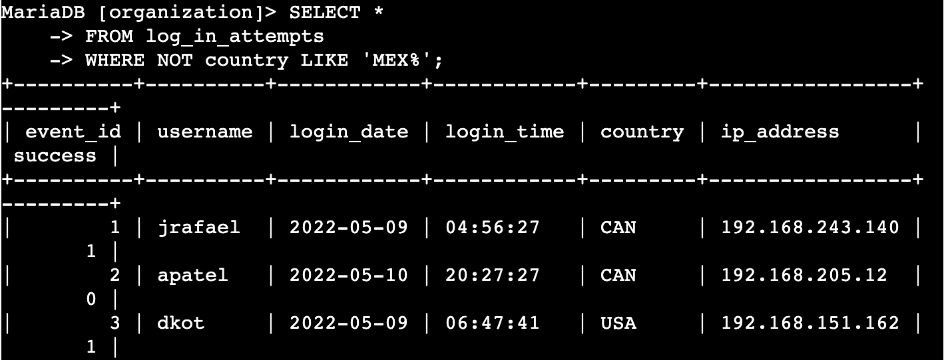
How the query works: To exclude all variations of Mexico (such as "MEX" and "MEXICO"), I used the NOT LIKE operator combined with the % wildcard. The pattern 'MEX%' catches any string starting with those three letters. By applying NOT, I successfully filtered out all attempts from Mexico, allowing me to investigate other geographical sources.

Retrieve employees in Marketing
I needed to identify employees in the Marketing department who work in the East building to perform security updates on their machines.
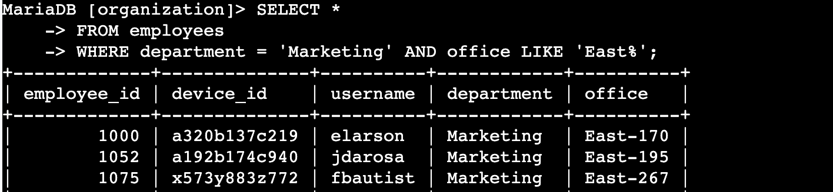
How the query works: This query uses AND to combine two requirements. First, it filters the department column for 'Marketing'. Second, it uses the LIKE operator with the wildcard pattern 'East%' on the office column. This ensures that any office located in the East building (e.g., East-170, East-320) is included in the results.

Retrieve employees in Finance or Sales
The team needed to perform a different update for employees in either the Sales or Finance departments.
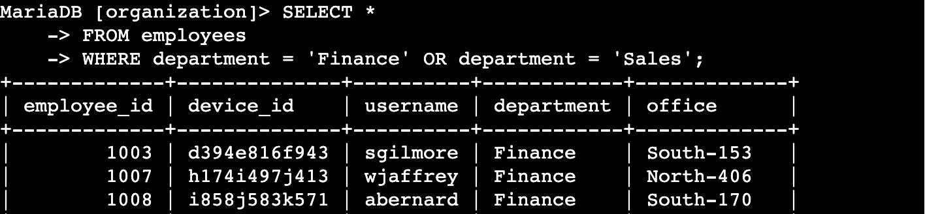
How the query works: This query utilizes the OR operator to filter the department column. Because an employee cannot be in two departments at once in this schema, OR is used to pull all records that match either 'Sales' or 'Finance', ensuring both groups are captured for the update.

Retrieve all employees not in IT
The Information Technology department already received a specific update. I needed to identify all other employees who still required it.
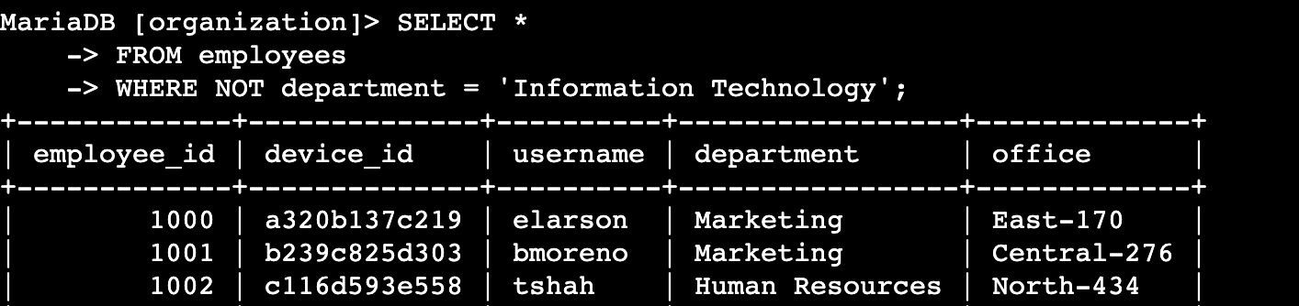
How the query works: This query uses the NOT operator to exclude a specific condition. By filtering for NOT department = 'Information Technology', the query returns every employee record in the database except for those in the IT department. This is a more efficient way to target multiple departments at once when only one needs to be excluded.

Summary
Throughout these tasks, I applied SQL filters using AND, OR, NOT, and LIKE to precisely target data within an organization's database. I successfully isolated suspicious login activity based on time, date, and country, while also organizing employee data for critical security updates. These exercises highlight how SQL serves as a fundamental tool for security professionals to monitor systems and maintain machine integrity across various departments.

